65.07.22a
Transfer of Title
archival location?, SA.

(C)
CERTIFICATE OF TITLE
Register Book
Vol. XLV Folio. 207

Ferdinand Jacob Heinrich Müller of Melbourne in the Province of Victoria is now seised of an estate in fee simple subject nevertheless to such encumbrances liens and interests as are notified by memorial underwritten or endorsed hereon in Those pieces of land situated in The Hundred of Macclesfield and Bremer County of Hindmarsh and bounded as appears in the plan in the margin hereof and therein colored green That is to say First in that piece of land containing two roods or thereabouts portion of the allotment 133 in the Township of Macclesfield and measuring as well on the northwesterly side next other part of the said allotment as on the southeasterly side next the allotment 132 severally three chains and twenty links or thereabouts and as well on the northeasterly side next portion of allotment 138 as on the southwesterly side next Luck Street severally one chain and sixty links or thereabouts and Second in that piece of land containing two acres and seven perches or thereabouts comprising the allotments 23 and 24 of the section 2607 in the Hundred of Bremer laid out as the Township of New Hamburgh and measuring on the north side next a street seven chains or thereabouts on the south side next a street six chains and sixty links or thereabouts on the east side next a street three chains or thereabouts and on the west side the said piece of land is bounded by the River Angas Which said piece of land is bounded as appears in the plan deposited in the General Registry Office No. 129 of 1856 Which said allotment and section is delineated in the Public Map deposited in the Office of the Surveyor General and were originally granted as to the said allotment on the ninth day of August 1850 under the hand and seal of Sir Henry Edward Fox Young Lieutenant Governor of the said Province to John Marriott Davenport and Henry Devereux Davenport and as to the said section 2607 on the sixteenth day of November 1841 under the hand and seal of George Grey Esquire Resident Commissioner and Governor of the said Province to Patrick James Todd

In witness whereof, I have hereunto signed my name and affixed my seal this sixteenth day of November one thousand eight hundred and sixty three
W B T Andrews
Acting Registrar-General

Signed, the 16th day of Novr 1863 in presence of H P Denton

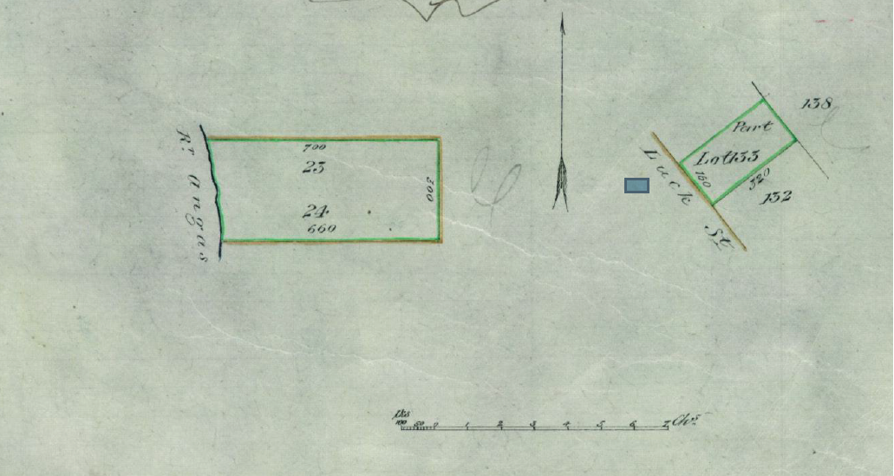

Transfer No. 11035 dated 12 July 1865 produced the 22 day of July 1865 at noon from the within named Ferdinand Jacob Heinrich Müller to Charles Crouch of New Hamburgh laborer of the within allotments 23 & 24 Consideration money paid £25.
Entered the 22 day of July 1865 at noon
W B T Andrews Acting Regr General
This Certificate of Title is cancelled as regards lots 23 and 24 for which a new Certificate of Title is issued Vol. LXX Folio 197
W B T Andrews Acting Regr General

Transfer No. 24254 from Ferdinand Jacob Heinrich von Müller formerly Ferdinand Jacob Heinrich Müller to Heinrich Friedrich Wilhelm Dancker of the within part Lot 133. Produced 14 day November 1868 at Ten o'clock a.m.
W Bacon Carter Depy Registrar General
Cancelled as regards the land comprised in Transfer No. 24254
W Bacon Carter Depy Registrar General
A New Certificate of Title issued for the land comprised in Transfer No. 24254 Vol: CXXII Folio 117
W Bacon Carter Depy Registrar-General

Document headed by coat of arms of SA. MS bears a tick and a pencilled annotation: '1867'.
The seal of the 'Registrar General South Australia' is next to the signature.
The plans of the land described are at the bottom of the first page of the title document: 65-07-22a_image01.jpg.

